Asimov, The Shaping of North America, Houghton Mifflin 1973 First Edition stated First print. As new unclipped dust jacket price $5.95 in mylar. As new hard cover with all 261 pages tightly bound and no marks of any kind. 8vo ISBN 0395154936

ID 000365 Price $135 Box 27

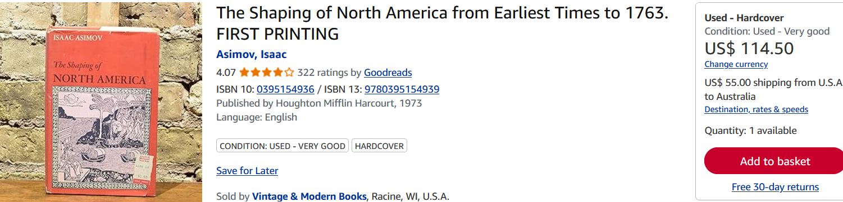
AbeBooks only two first ed hole in dust jacket other ExLib
Amazon $35
Vintage and Modern $98

